**”Ticket to Work”- Monthly Earnings Tracking Sheet**

**Instructions:** For each month worked, list your gross earnings amount for **each paycheck you receive monthly.** When completed, rename this document using your full name by using “Save As” under the “File” tab and send a completed copy to: abbottcreditsolutions@gmail.com **Continue to report your paystubs to SSA & EN Case Manager every month**.Thank you.

***Sample of Paycheck***

***How to Save Your Document***

1. ***Go to the “File” tab & select “Save As.”***





1. ***Next, Select “Computer or Desktop” where you want to store your document***

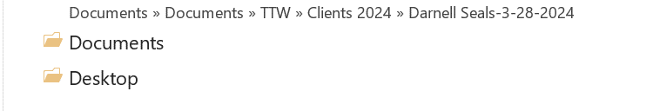

1. ***Type in your Name in the “File Name” text box. Then “Save”***

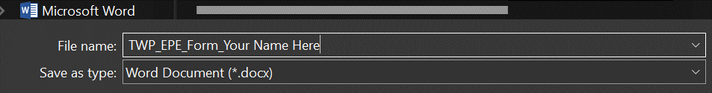

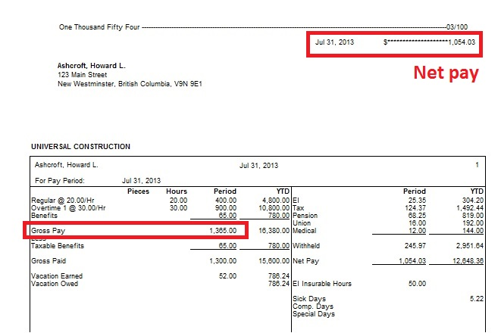

**Use this amount for your gross paycheck amount in the boxes below.**

1. **Enter Your Information Below. Please complete all questions asked.**

Date:       Participant Full Name:      Email:       Social Security #:       Type of Disability Benefit

Entitlement (Date (month & year) of receiving your SSDI or SSI cash and medical benefits):

Employer/Company Name:       City:       Date of Hire(Day/Month/Year):

Position Hired For:       Wages/Hour:       Total Hours/Week:

Date Individual Work Plan Intake Signed:

***For Office Use Only-Do Not Enter Any Information Here.***

Trial Work Period (First month of gross earnings over $1110.00/for 2024 or $1050.00/ for 2023) =

Extended Period of Eligibility =       (Starting at month 10 of employment) EXR (37th month)

**Trial Work Period**

| **Year** | **Jan** | **Feb** | **Mar** | **Apr** | **May** | **June** | **July** | **Aug** | **Sept** | **Oct** | **Nov** | **Dec** |
| --- | --- | --- | --- | --- | --- | --- | --- | --- | --- | --- | --- | --- |
| 2023  Paycheck # 1 |  |  |  |  |  |  |  |  |  |  |  |  |
| Paycheck #2 |  |  |  |  |  |  |  |  |  |  |  |  |
| Paycheck #3 |  |  |  |  |  |  |  |  |  |  |  |  |
| Paycheck #4 |  |  |  |  |  |  |  |  |  |  |  |  |
| Totals |  |  |  |  |  |  |  |  |  |  |  |  |

**Trial Work Period or**

**Extended Period of Eligibility (EPE) – starts with “month 10” of employment**

| **Year** | **Jan** | **Feb** | **Mar** | **Apr** | **May** | **June** | **July** | **Aug** | **Sept** | **Oct** | **Nov** | **Dec** |
| --- | --- | --- | --- | --- | --- | --- | --- | --- | --- | --- | --- | --- |
| 2024  Paycheck # 1 |  |  |  |  |  |  |  |  |  |  |  |  |
| Paycheck #2 |  |  |  |  |  |  |  |  |  |  |  |  |
| Paycheck #3 |  |  |  |  |  |  |  |  |  |  |  |  |
| Paycheck #4 |  |  |  |  |  |  |  |  |  |  |  |  |
| Totals |  |  |  |  |  |  |  |  |  |  |  |  |

**Extended Period of Eligibility (EPE) – starts with “month 10” of employment**

| **Year** | **Jan** | **Feb** | **Mar** | **Apr** | **May** | **June** | **July** | **Aug** | **Sept** | **Oct** | **Nov** | **Dec** |
| --- | --- | --- | --- | --- | --- | --- | --- | --- | --- | --- | --- | --- |
| 2025  Paycheck # 1 |  |  |  |  |  |  |  |  |  |  |  |  |
| Paycheck #2 |  |  |  |  |  |  |  |  |  |  |  |  |
| Paycheck #3 |  |  |  |  |  |  |  |  |  |  |  |  |
| Paycheck #4 |  |  |  |  |  |  |  |  |  |  |  |  |
| Totals |  |  |  |  |  |  |  |  |  |  |  |  |

**NOTE: When Completed for all months worked up to the current date, save a copy for yourself and send a copy to:** [**abbottcreditsolutions@gmail.com**](mailto:abbottcreditsolutions@gmail.com)**. You will be completing this calendar throughout the Ticket to Work program for verification of earnings so update this calendar monthly and provide updated copies to your EN every three months. Thank you!**